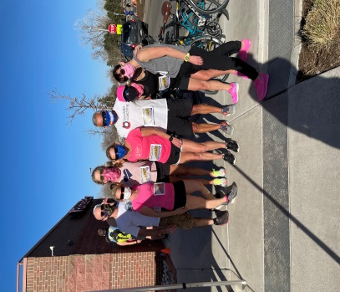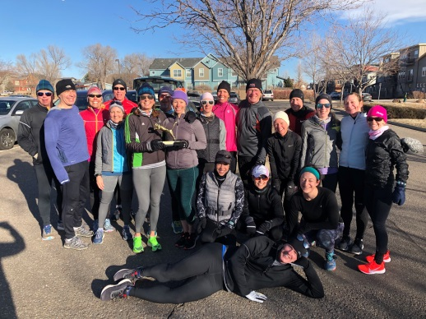

Training Details
- 19 Week Training Program…3 weeks Base and 16 weeks of Group Workouts (May 31st thru Oct 10th)
- Training begins the week of May 31st (schedule posted on front page of website).
- FIRST MEETING – Wed June 2nd
- There will be 2 Training Groups BASED on MEETING times: morning and evening with all abilities welcome
  - evening meets Wed @ 5:30 pm and Sat @ 7:00 am
  - morning meets Wed @ 6:30 am and Sat @ 7:00 am
- Train with other Boulder Strider Members at your goal pace in a non-intimidating atmosphere
Boulder Striders’ Program Rates
Early Bird Special Pay by June 4th | $375  $350 | Twice/week - 3 weeks base /16 weeks of twice a week training  Once/week – 3 weeks base/16 weeks of once a week training
Regular Price  Starts June 5th | $400  $375 | Twice/week - 3 weeks base /16 weeks of twice a week training  Once/week – 3 weeks base/16 weeks of once a week training
MAKE CHECKS PAYABLE TO: BOULDER STRIDERS
OR CREDIT CARD...ADD $12 TO THE PROGRAM RATE
VENMO…paid to @Darren-DeReuck
Please Print & Mail Registration (postmarked June 4th to get early bird) to:
Boulder Striders, 4162 Saint Croix St, Boulder, CO 80301
2021 Summer Registration Form
Last Name |  |  |  |  | First Name
Address
City |  |  |  | State |  |  |  |  |  | Zip
DOB |  |  | Email
Day Phone
 | Evening: Wed/Sat (5:30 pm /7:00 am ) |  |  |  |  |  | Morning: Wed/Sat (6:30 am / 7:00 am )

By signing this Registration Form, I do not hold Colleen De Reuck, Boulder Striders or any of the Coaches liable for injury to myself during the 19 week training. One Form per Member…Photocopies are good.

Signature: __________________________________________

